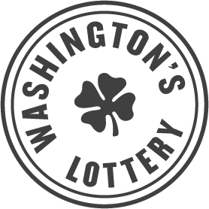

NOTICE OF BID OPPORTUNITY

Competitive Solicitation RFP090
Annual Financial Auditing Services

COMPETITIVE SOLICITATION POSTING: October 26, 2021
DEADLINE FOR SUBMITTING BIDS: December 2, 2021

Find the full solicitation on Washington’s Electronic Business Solution (WEBS). Vendors not registered in WEBS will not receive updates or amendments to the solicitation, which could disadvantage your bid.
Contract location: Washington’s Lottery
Contract description: The Washington’s Lottery is conducting a competitive procurement to award a contract to acquire an external auditor to complete an Annual Financial Audit to ensure transparency and public trust.
Commodity codes: 946-20 Auditing, 958-39 Financial Management Services, 918-49 Finance/Economics Consulting.
Preference/priority points:
- 3% Washington small businesses
- 3% Veteran-owned businesses
- 1% Executive Order 18-03
Solicitation documents: Solicitation documents, contacts and bid instructions are available in WEBS: https://pr-webs-vendor.des.wa.gov/.
Question-and-answer period: October 27, 2021 – November 8, 2021. Submit questions or concerns about this solicitation in writing to the Procurement Coordinator: Jenna Johnson at Bids@walottery.com.

