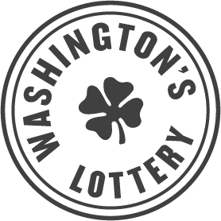

NOTICE OF BID OPPORTUNITY

Competitive Solicitation RFP112
Random Number Generators

COMPETITIVE SOLICITATION POSTING: October 19, 2021
DEADLINE FOR SUBMITTING BIDS: December 2, 2021, 2:00 P.M. Pacific Time

Find the full solicitation on Washington’s Electronic Business Solution (WEBS). Vendors not registered in WEBS will not receive updates or amendments to the solicitation, which could disadvantage your bid.
Contract description: The Washington’s Lottery is conducting a competitive procurement to award a Contract for three (3) new draw machines also known as Random Number Generators (RNG), for the purpose of facilitating lottery drawings and to ensure the randomness of Lottery draw games.
Through this contract established by this solicitation, Washington’s Lottery may obtain hardware, software, and supplies necessary to operate and maintain a system that generates random numbers in compliance with various game matrices. The proposed RNGs must be stand -alone units and not connect to the internet.
Commodity codes: 578-53-Lottery Equipment and Supplies, 958-66-Lottery Management Services, 931-88 Vending Machine Maintenance etc.
Preference/priority points:
- 3% Washington small businesses
- 3% Veteran-owned businesses
- 1% Executive Order 18-03
Solicitation documents: Solicitation documents, contacts and bid instructions are available in WEBS: https://pr-webs-vendor.des.wa.gov/.
Question-and-answer period: October 19, 2021 – November 12, 2021. Submit questions or concerns about this solicitation in writing to the Procurement Coordinator: Jenna Johnson, bids@walottery.com

