- The ability for players to pay with Debit will be added to all Lottery vending machines in the coming months.
- We are also updating all vending machines to purchase via a shopping cart. Players will add tickets to their cart and then select checkout.
- Example:
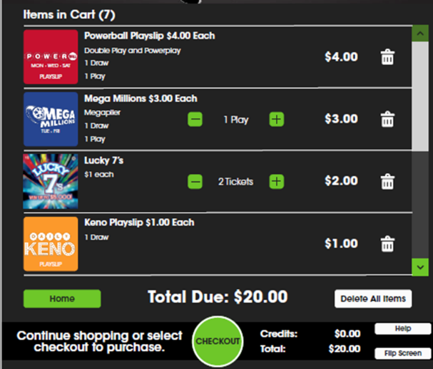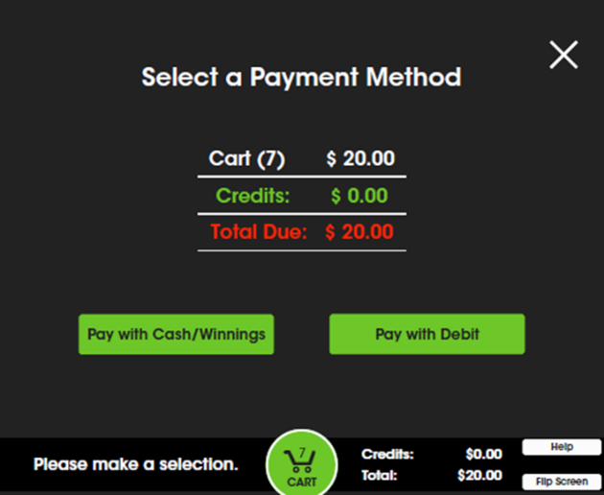

- Below are examples of where you will see the Debit card sales on reports.
- Debit will function much like reinvestment, the sales will be included in the game breakdown then a credit is applied to your account.
- Washington’s Lottery is paying the transaction fee for Debit purchases made at our vending machines so there is no added cost to you.
- The player will be directed to Washington’s Lottery for credit if any issue arises during the debit transaction ticket printing. A receipt will print automatically with instructions. If the printer is jammed and cannot print, stores will have the ability to reprint the receipt once the printer jam is cleared by going to Reprint>last transaction.
- Players will be limited to $700 in spending per card during a 7-day period. The $500 per session is a different setting and still applies as well.
- Players will not be able to do a split payment type, if they select Debit the entire purchase is made that way. If they select cash/reinvestment (winnings) they cannot pay a portion in debit also.
- All draw tickets purchased with Debit from the vending machine are non-cancellable. If the store attempts to cancel a draw ticket at the GT1200 they will get an error message.
- Additional information and store training will be provided based on your locations “go live” date.

Weekly Sales Report
Debit Card sales will include both Draw and Scratch sales
PDF Format
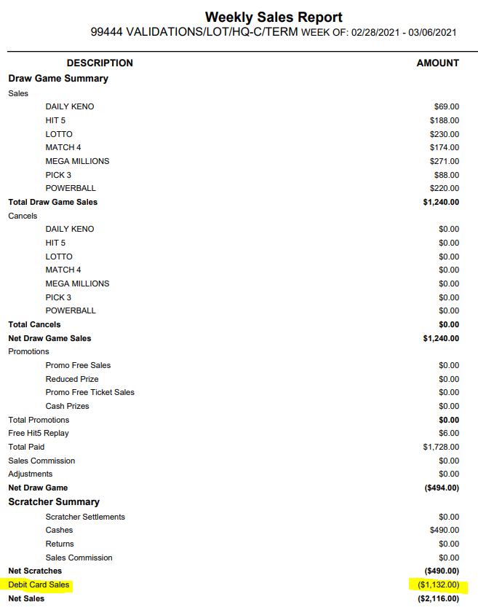
CSV Format – End of the string just before Net Sales
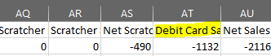

Weekly Settlement Report
PDF Format – Debit sales will be broken out between Draw and Scratch
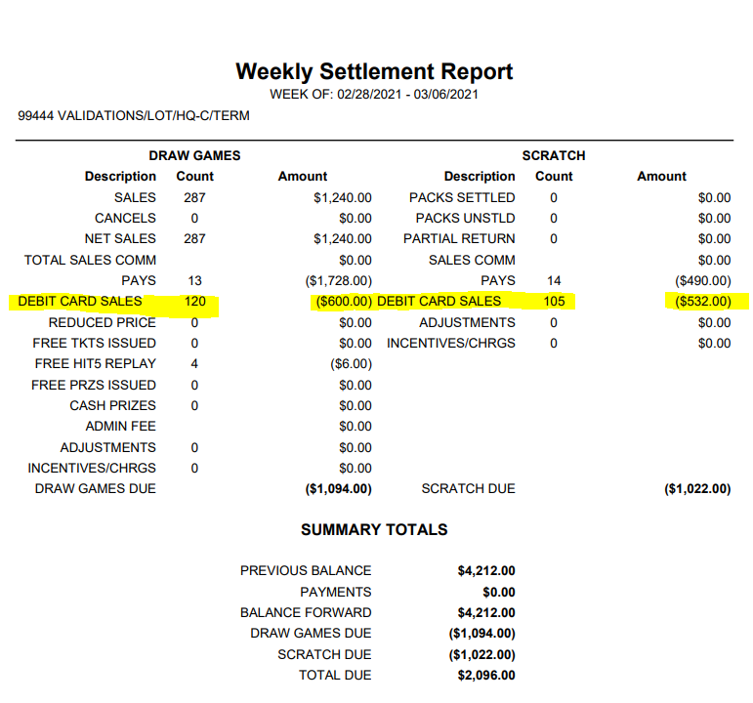
CSV Format
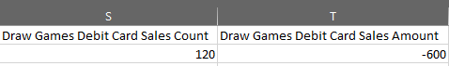

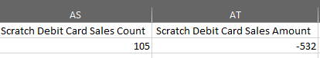

Weekly and Monthly Statements
Debit Card sales will include both Draw and Scratch sales for the total but will be included in the Pays column for each day.
PDF Format
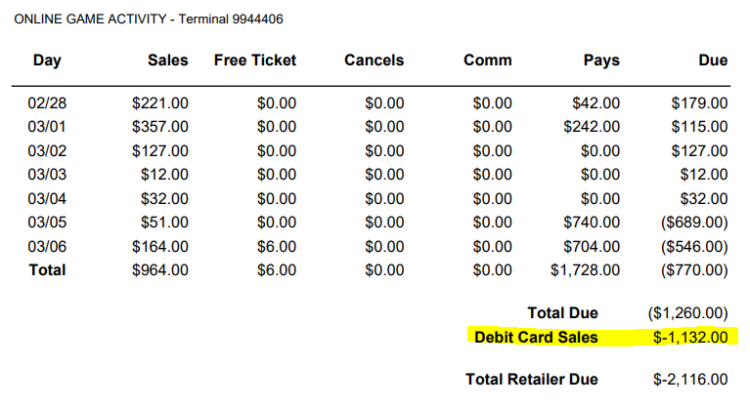
CSV Format – Debit card sales by the day and by terminal if more than one vending machine
